
SAFEGUARDING POLICY STATEMENT
__________________________________________________________________

The safeguarding of all is at the heart of our collective mission and is everyone’s responsibility. The Diocese of Northampton and its leaders are fully committed to safeguarding and promoting best practice.
Every human being has a value and dignity which we as Catholics acknowledge as coming directly from God’s creation of male and female in his own image and likeness. We believe therefore that all people should be valued, supported, and protected from harm and have a zero-tolerance approach to all abuse, recognising the possible escalation of low-level concerns into more serious incidents if not addressed.
Our parish is committed to the policy of the Catholic Church in England and Wales to report to the statutory authorities all allegations of abuse made against those working in the name of the Church, regardless of whether the allegations or concerns relate to a person’s behaviour in relation to their role within the Church or another setting.
It is also the policy to report to statutory authorities where a child or an adult is at immediate risk of harm, or there is concern that a child is suffering or is likely to be suffering from significant harm, from somebody who does not hold a role within the Church.
We further aim to prioritise the voice and well-being of victims and survivors both as a diocese and our leadership. Further information is contained within our Commitment to Victims and Survivors.
Further information in relation to National Safeguarding Policies and Practice Guidance, established by the Catholic Safeguarding Standards Agency, which the Northampton Diocese adheres to, as part of the ‘One Church Approach’ to safeguarding can be located using
https://catholicsafeguarding.org.uk/resources/national-safeguarding-policy/
In addition, the Diocese and our parish is committed to achieving compliance with the National Safeguarding Standards for the safeguarding and protection of children, and adults who may be vulnerable or at risk and can be accessed using https://catholicsafeguarding.org.uk/resources/the-eight-national-safeguarding-standards/
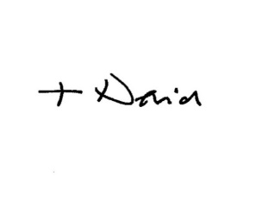
Signed:

Rt Revd Dr David J Oakley

Bishop of the Catholic Diocese of Northampton

